**Convert XPS to PDF in .NET Core Using Syncfusion**

The Syncfusion® PDF library is a [.NET PDF library](https://www.syncfusion.com/pdf-framework/net/pdf-library) used to create, read, and edit PDF documents programmatically without Adobe dependencies This guide demonstrates how to perform SVG to PDF conversions efficiently.

**Steps to convert SVG to PDF programmatically:**

1**. Create a New Project**: Start a new Console application in .NET Core to facilitate the HTML-to-PDF conversion process. 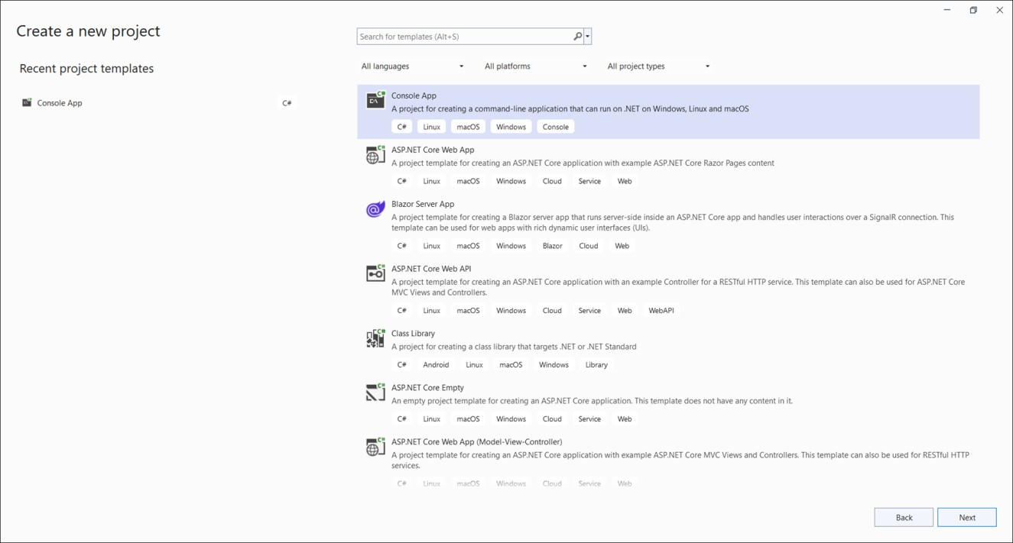

2. **Install Required Packages**: Add the [Syncfusion.XpsToPdfConverter.Net.Core](https://www.nuget.org/packages/Syncfusion.XpsToPdfConverter.Net.Core) NuGet package from [NuGet.org](https://www.nuget.org/) to your project.

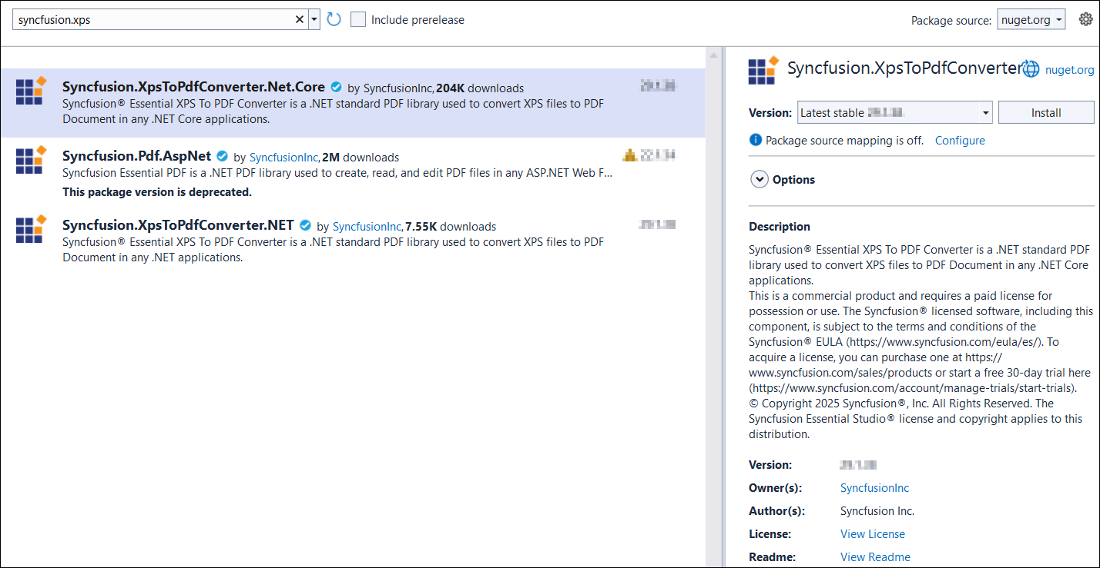

3. **Add Necessary Namespaces**: Include the essential namespaces in your **Program.cs** file

**C#**

|  |
| --- |
| **using** Syncfusion.Pdf;  **using** Syncfusion.XPS; |

4. **Implement the Conversion Logic**: Utilize the following code to convert XPS documents to PDFs

**C#**

|  |
| --- |
| // Initialize XPS to PDF converter  XPSToPdfConverter converter = new XPSToPdfConverter();  // Open the XPS file as stream  using (FileStream fileStream = new FileStream("Input.xps", FileMode.Open, FileAccess.ReadWrite))  {  // Convert the XPS to PDF  PdfDocument document = converter.Convert(fileStream);  // Creating the stream object  using (MemoryStream stream = new MemoryStream())  {  // Save the document into stream  document.Save(stream);  // Set the stream position to '0' to ensure it's not empty  stream.Position = 0;  // Define ContentType for the PDF file  string contentType = "application/pdf";  // Define the file name for download  string fileName = "Output.pdf";  // Create a FileContentResult object for the PDF  FileContentResult fileResult = new FileContentResult(stream.ToArray(), contentType)  {  FileDownloadName = fileName  };  // Return the file result  return fileResult;  }  // Close the document  document.Close(true);  } |

A complete work sample for convert XPS document to PDF can be downloaded from [XPSToPDFSample.Zip.](https://www.syncfusion.com/downloads/support/directtrac/general/ze/XpsToPdfSample-1983802374.zip)

By executing the program, the output PDF document will be generated as shown below.

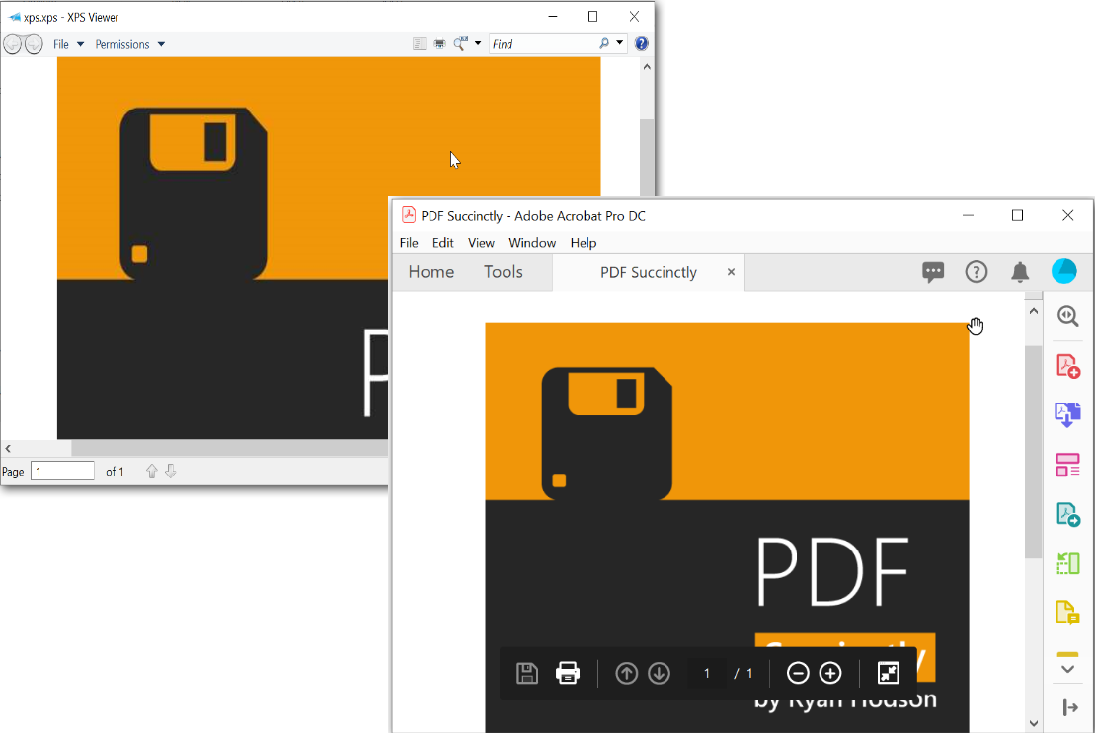

Take a moment to peruse the [documentation](https://help.syncfusion.com/file-formats/pdf/working-with-document-conversions#converting-xps-document-to-pdf), where you will find other options like convert[word to pdf](https://help.syncfusion.com/file-formats/pdf/working-with-document-conversions#converting-word-documents-to-pdf), convert [excel to pdf](https://help.syncfusion.com/file-formats/pdf/working-with-document-conversions#converting-excel-documents-to-pdf) ,convert [RTF to pdf](https://help.syncfusion.com/file-formats/pdf/working-with-document-conversions#converting-rtf-documents-to-pdf)  and convert [TIFF to pdf](https://help.syncfusion.com/file-formats/pdf/working-with-document-conversions#converting-tiff-to-pdf).

​**See Also:**

​[How to convert XPS to PDF document](https://www.syncfusion.com/kb/9077/how-to-convert-xps-to-pdf-in-c-vb-net)

[How to convert RTF to PDF using C# and VB.NET](https://www.syncfusion.com/kb/9556/how-to-convert-rtf-to-pdf-using-c-and-vb-net)

[How to convert Excel to PDF in C#, VB.NET](https://www.syncfusion.com/kb/9090/how-to-convert-excel-to-pdf-in-c-vb-net)

[How to convert OXPS to PDF](https://www.syncfusion.com/kb/7479/how-to-convert-oxps-to-pdf)

[How to convert TIFF to PDF in C# and VB.NET](https://www.syncfusion.com/kb/9547/how-to-convert-tiff-to-pdf-using-c-and-vb-net)

Note:

Starting with version **16.2.0.x**, if you reference Syncfusion® assemblies from the trial setup or the NuGet feed, you must include a valid license key in your projects.  
Refer to the [documentation](https://help.syncfusion.com/common/essential-studio/licensing/license-key) to learn how to generate and register the Syncfusion® license key in your application to use the components without displaying a trial message.

**Conclusion**

I hope you enjoyed learning about how to convert XPS to PDF document in .NET Core.

You can refer to our [**ASP.NET Core PDF feature tour**](https://www.syncfusion.com/document-processing/pdf-framework/net-core) page to know about its other groundbreaking feature representations and documentation, and how to quickly get started for configuration specifications. You can also explore our [**ASP.NET Core PDF Example**](https://www.syncfusion.com/demos/fileformats/pdf-library) to understand how to create and manipulate data.

For current customers, you can check out our components from the [**License and Downloads**](https://www.syncfusion.com/sales/teamlicense) page. If you are new to Syncfusion®, you can try our 30-day [**free trial**](https://www.syncfusion.com/downloads/fileformats/confirm)to check out our other controls.

If you have any queries or require clarifications, please let us know in the comments section below. You can also contact us through our [**support forums**](https://www.syncfusion.com/forums/), [**Direct-Trac**](https://support.syncfusion.com/create), or [**feedback portal**](https://www.syncfusion.com/feedback/aspnet-core?control=pdf). We are always happy to assist you!